24.68: a) 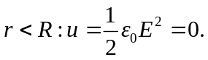
b) 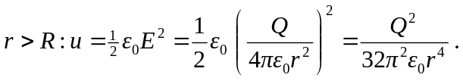
c) 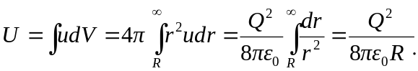
d) This energy is equal to 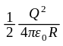 which is just the energy required to assemble all the charge into a spherical distribution. (Note, being aware of double counting gives the factor of 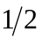in front of the familiar potential energy formula for a charge Q a distance R from another charge Q.)
e) From Equation (24.9): 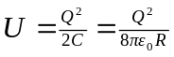 from part (c) 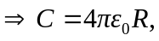 as in Problem (24.67).

